*Pre Submission Report*

TASK: WEBPAGE DESIGNING.

Topic:

Personal

Album

Subject: CSE (326).

Section: K19KX.

**Group Members:**

1. 66 Varun Gaur 11911046
2. 64 Shubham Bharti 11910985
3. 67 Suman SK 11911060
4. 65 Srinivasa Rao 11910999

MODULES:

1.The Layout of the Homepage.

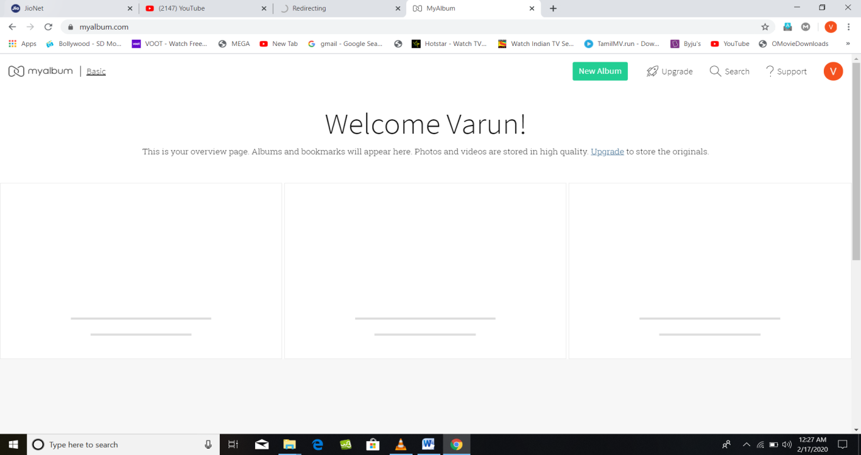

2.Various links and subparts of the webpage:

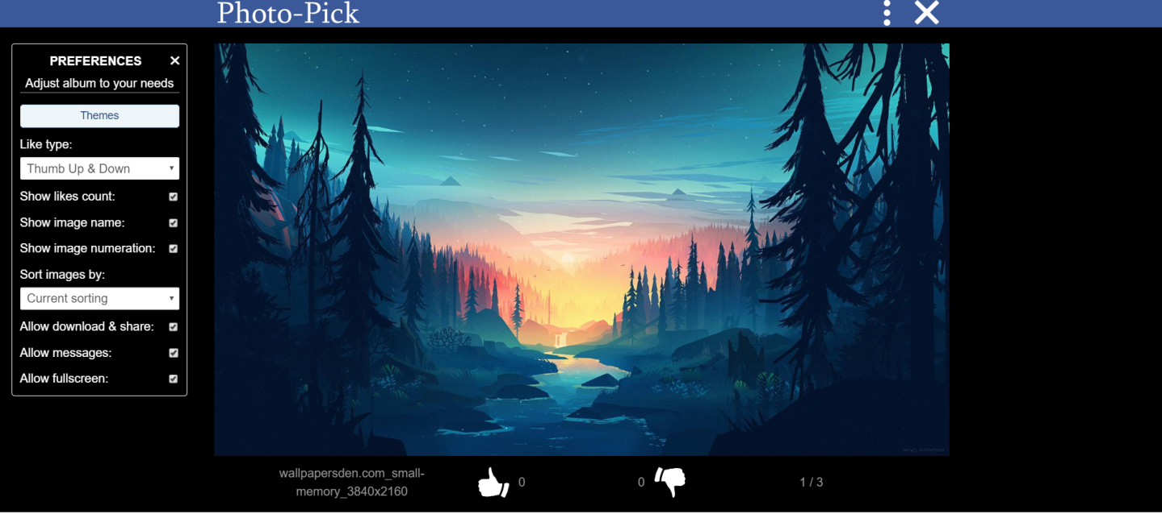

3. Adding media to our webpage.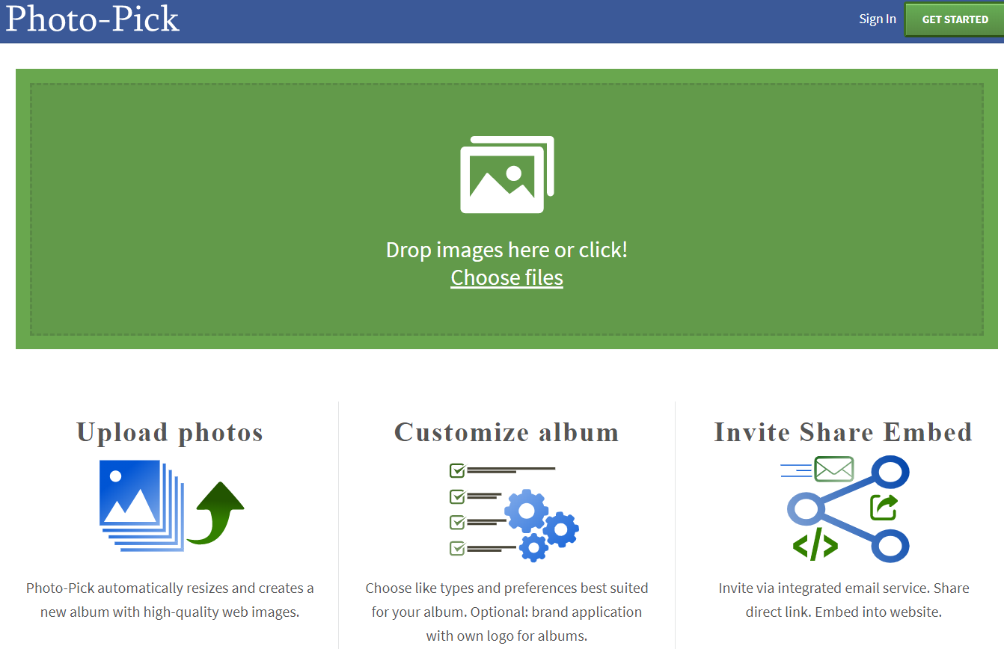

4.Sophisticated Formatting

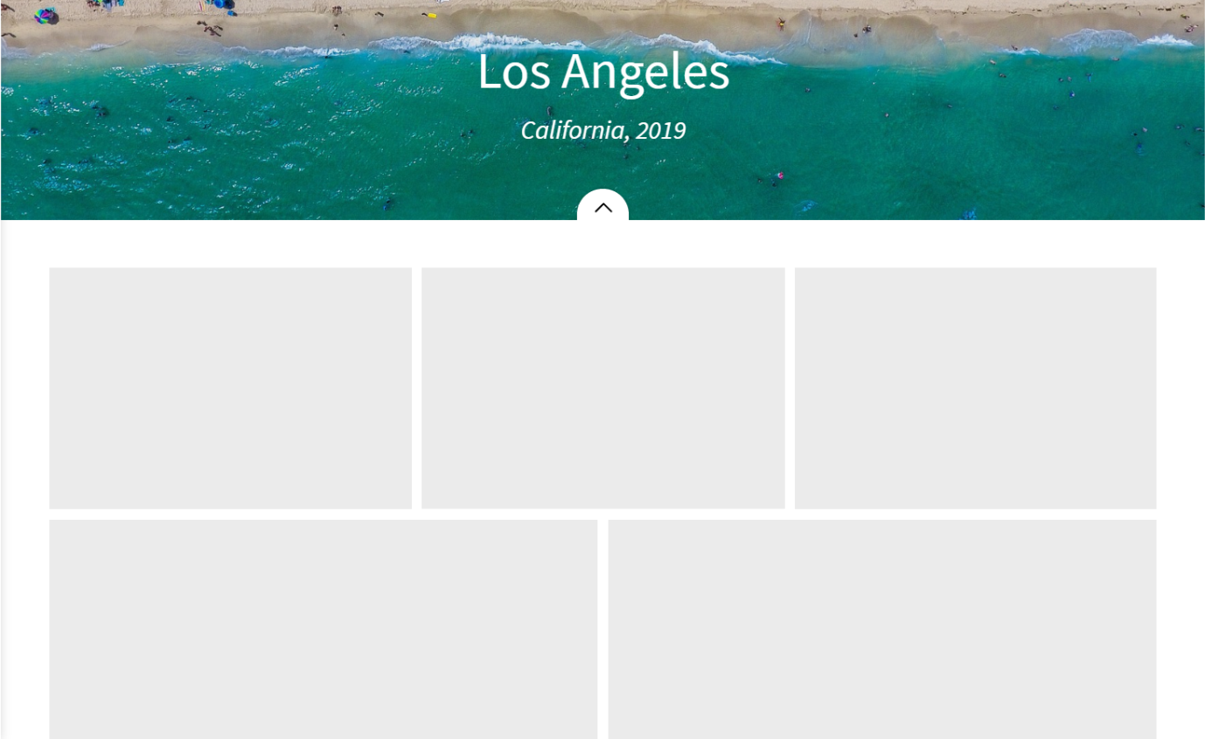

* Proper spacings and informative.
* Using colours to make it more attractive.

JOB DISTRIBUITION

* Description: The task each group member is going to perform is distributed evenly, he has a specific aspect of the webpage to design.

Varun and shubhham are going to design the basic setup of the webpage, suman and srinivasa are going to look after the formatting and shubham and varun are going to manage the media and the links. The webpage requires multiple media components such as images and video previews. It also has multiple links and various sections which give out information about the personal photo collection.

The webpage will be user friendly and informative. The user will be able to upload their photos and videos and can create an album from their collection.